Deakin University

Bachelor of Software Engineering

SEJ 123 Data Capture Technologies (2022 Trimester 2)

Technical Report on the Final Project (Mini weather station)

Student Name: YIZHENG HE

Student ID: 221411294

Table of Contents

Issues and Assumptions 3

Detailed explanation of the strategy 3

Data collection process 4

Ethical issues with the project 5

Results & Discussion 6

Challenges & Lessons learned 7

Proposals for potential project expansions. 7

Issues and Assumptions

As the strange weather continues, the relative humidity indoors is becoming higher. Mold development may happen very quickly, and the unpleasant "stickiness" that it produces can be a consequence. Molds are the most common cause of bad air quality found within buildings, including homes and places of business. It is possible that they will make asthma and other respiratory illnesses worse. However, dry air may be hazardous to your health and can even cause damage to your home. When the relative humidity is lower than 40%, wood floors, walls, and even metal elements are at risk of suffering damage that may be either indirect or direct. Having dry skin may be a source of significant discomfort. A lack of humidity in the home may hasten the drying process of wood, which may result in the material being warped and cracked.

When used in the real world, temperature and humidity sensors perform more complex tasks than just determining the temperature of an object's surface or the temperature of the air in a particular space. In addition to monitoring temperatures, the majority of temperature sensors also check to see that a process remains contained within a predetermined range. In particular, temperature sensors play an important part in preventative dependability since they monitor the state of the system and notify operators of any imminent risk or breakdown.

Detailed explanation of the strategy

Now, construct a temperature and humidity sensor. Clearly, the DHT11 sensor was employed in the construction of this edifice. This affordable sensor's functionality is equivalent to that of commercially available temperature sensors, despite the fact that it costs only $5 AUD. It simply fits the Arduino's requirements for temperature and humidity measurement. In addition, an LCD keyboard shield is used in this project to display the current temperature and humidity.

The Arduino Mega 2560 was selected as the primary device for this project for a number of reasons, including the fact that it has more flash memory than A, a higher memory capacity, and is now deemed superior than the UNO R3 in terms of performance and use.

After that, the DHT11 sensor should be used. This temperature sensor is used in the project to detect both the temperature and the humidity.

The DHT11 is equipped with three distinct pins. One for ground, one for the power supply voltage, and one for signal output. To make the data readily accessible, we will connect these pins to the Arduino Mega. This will enable data to be sent from the Arduino Mega to the LCD keyboard shield module. The resistors must be connected to five volts and then to the Arduino's ground. Let's now attach a signal output, and because the signal may travel anywhere, I'll choose 24. let's finally attach a signal output. The project we are now working on is powered by a nine-volt battery.

Temperature and humidity measurements have both hit 67%, with temperature at 23.1 degrees and humidity at 67%. When the windows are opened for a few minutes, the real temperature and humidity readings of the environment stabilize, and the findings are compared to the measurements taken outside. This occurs because the inside heater is on.

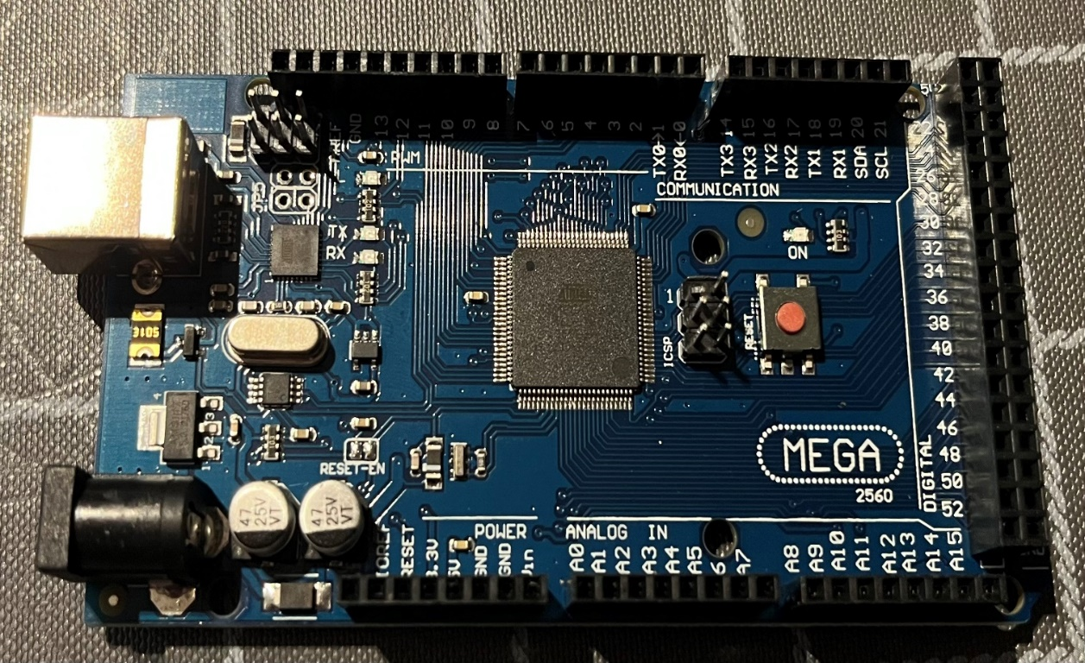Arduino Mega 2560

9v battery LCD Keypad Shield

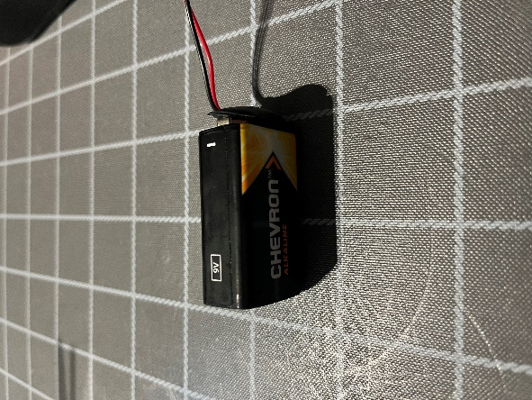

Actual hardware installed environment DHT11 and PLUG TO SOCKET JUMPER Line

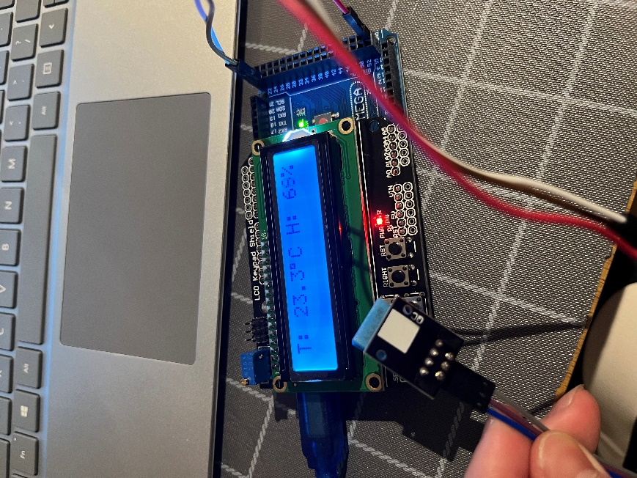3

Collection Process Data

Constructing an Arduino data logger and gaining an understanding of how to log information for a certain amount of time will be the focus of this project. The information, which includes the temperature, humidity, date, and time, will be taken from an Arduino development board and stored on an SD card as well as a personal computer.

You could acquire the information in a handy Excel file that you can use for further research. The DHT11 sensor will be used to detect temperature and humidity, and the DS3231 generic RTC module will be used to keep track of the time. Both sensors can be found here. At the end of the project, you will have the knowledge and abilities required to store data such as date, time, and sensor readings onto an SD card, and then publish that data directly to an Excel sheet through serial connection when you have completed the project. It is not necessary to have the DHT11 temperature sensor. Using an LM35 and an Arduino, you can obtain a readout of the current temperature.

I2C (SCL, SDA) is used for communication between the Arduino and the real-time clock module DS3231, while SPI is used for communication between the SD card module and the Arduino (MISO, MOSI, SCK, CS). Pins 4 and 7 are set up as the control signal and output pins, respectively, when the Arduino software is first installed; however, these pins may be reprogrammed to do anything else. As was just said, the final objective of this project is to save the current time as well as the temperature and humidity readings on an SD card. According to the information shown in the table that follows, our Arduino will be able to read all four parameters with the assistance of the DS3231 library and the DHT11 library, and it will then record those readings in the parameters that are appropriate for them.

Ethical issues with the project

SENSE-THINK-ACT Situational Analysis of the Issue Temperature and humidity are two elements that might disturb people's everyday lives at home and at work. It's true that most people don't give this issue much attention, but when we do, we realize that conditions such as humid weather often lead to mold development inside, which may subsequently release harmful spores into the air. Or a lack of humidity in the air leads to structural alterations in the house. Explain the notion. To remedy the problem, I suggest placing micro weather stations in all our structures, including homes, businesses, and hospitals. This would make it much easier for people to stay in the building regardless of the weather outside. To overcome the security problem, the system should include fingerprint scanners and face recognition software. Individuals should no longer need to spend time or effort memorizing complicated passwords to keep their homes and workplaces secure. We can both agree that it is not as if you have suddenly forgotten your passwords. Gathering statistics and information the project cannot move forwards without user feedback and temperature and humidity data. Most of the time, this information is gathered so that project flaws can be fixed, and new features can be made better. Objections founded on moral grounds Information collection is one of the variables to consider. Collecting and entering information into the system might be a hectic endeavor. Interference is another unidentified issue. It is essential to consider possible threats, such as dogs, that might short out the sort out the circuitry. ReBy applying this approach in people's homes and workplaces, health is improved. A 3D-printed case could protect the chip's internal circuitry while the user stays in the best case for a long-term system.

Results & Discussion

Assumptions: High pressure and moisture and low temperatures lead to rain. Low-pressure air leads to clear skies.

Too high humidity will produce mold indoors which is hazardous to health, and too low humidity will cause problems with skin health and building materials. between 20% and 50% is a suitable humidity level.

The Mini Weather Station is a set of instruments that can record temperature and humidity conditions.

In this project, a number of weather instruments will be studied to determine the mechanism by which they work and an attempt will be made to build at least one weather instrument. They will be collected or built and used to record approximately 14 days of indoor temperature and humidity data. Analyzing the collected data may help find the right indoor temperature and humidity for people to live in. Study the effects of temperature and humidity on people by recording and analyzing the data..

The temperature and humidity data were collected at 8:00 am, 2:00 pm, and 8:00 pm for fourteen days from September 6th to September 20th. The average humidity was 29.85% at 8:00 pm, 28.37% at 2:00 pm, and 27.06% at 8:00 am. The average humidity for the total data was 28.43%, which is in line with a normal and comfortable living environment.

Challenges & Lessons learned

The most difficult aspect of building this project was figuring out how to present the gathered data in a particular format. This was a requirement of the project. The HC-06 Bluetooth module was acquired online with the goal of first using Bluetooth to collect data from a mobile device. This was the initial reason for the purchase.  wasted multiple days attempting to connect your Bluetooth device to your iPhone or computer but was unable to do so. Because there is a wide variety of Bluetooth module protocols, Apple products and other devices are typically incompatible with one another because they are not compatible with Bluetooth protocols. Even after attempting to use the Arduino UNO R3 to link the LCD and acquire access to the temperature sensor, the project's single most difficult difficulty turns out to be transferring the data to the LCD panel. Tin dots on the LCD keypad shield have to be connected to the temperature sensor's interface in order to function properly. The problem was fixed by using an Arduino Mega 2560 board that was better and had more ports.

Proposals for potential project expansions.

Suggestions for the development of this project in the future.

At this point, only the rudimentary functions for detecting temperature and humidity have been implemented, and their readings are being displayed on the screen in real time. The first option is to incorporate remote viewing, which requires the addition of a Wi-Fi module so that data can be transmitted to any device. Second, the utilization of 3D printing to produce an appropriate housing that can be used to further beautify and protect the product that is involved in the project while it is in use. In the end, the battery will be switched out for a rechargeable battery to make the device usable and environmentally friendly.